Medical and Sports Science Committee

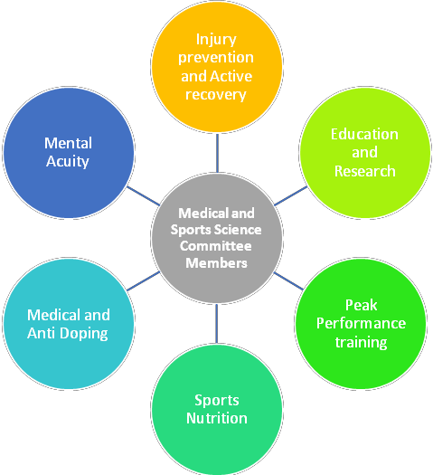
- Medical and Sports Science Committee Members
- Education and Research
- Sports Nutrition
- Medical and Anti Doping
- Mental Acuity
- Injury prevention and Active recovery
- Peak Performance training

# | Name | Role | Assignment
1. | Doctor Marisa Nimrod | Emergency Response, Acute Injury Management, advanced life support, 1 st Vice President of the Trinidad and Tobago Medical Association, Project  Management. | Chairman
2. | Roger Evelyn | Holistic Therapist, Bodywork, Partitioner and Sport  and Injury | Co Chairman
3. | Alexandria Olton | SportsTT – Exercise Psychologist | Consultant Only
4. | Asha De Freitas-Moseley | Certified Sports Medicine Athletic Trainer/Therapist | Policy Director
5. | Yohance Ayodike | Behavior Change Consultant | FIFA and Elite Referees
6. | Mannan Sedighi | Sport Science, Sport Nutrition, strength and  conditioning Coach | FIFA and Elite Referees
7. | Doctor Sergiy Adonin | MD, MCh(Tr&Orth), DM (orth), FRSC Ed  (tr&orth),PGDip Orth Sc Specialist Orthopaedic Surgeon | FIFA and Elite Referees
8. | Savaitri Rampersad | Medical Massage Therapist | FIFA and Elite Referees
Committee Members:
9. | Doctor Anyl Lloyd  Gopeesingh | MSC Sports And Exercise Medicine
10. | Doctor Joanne Ragoonanan | MSc Sports Medicine
11. | Doctor Terrance Babwah | MSc. Sport & Exercise Med(Univ Bath), MFSEM  (UK)
12. | Doctor Vernice Richards | Sports Psychologist

13. | Donald La Guerre | Sport and Exercise Psychology B.Sc.
14. | Gregory Seals | Sports Performance Specialist
15. | Janelle Bruno | Registered Dietitian
16. | Commander Doctor Israel  Dowlat | Bachelor of Medicine and Bachelor of Surgery (M.B.B.S)
17. | Martin Sedighi | Sports Management – Futsal Director
18. | Tracey Pierre | Sport and Exercise Nutrition
19. | Cherice Bronte-Tinkew | Registered Dietitian
20. | Arielle Pounder | Registered Dietitian And Personal Trainer

